**ASSESSMENT 03**

**NAME : NAVEETH KHAN J**

**DATE : 01/09/2024**

**Problem Statement:**

Create two variables InputValue and OutputValue, get the value of InputValue from user, Now by using Macro READBIT read last 4 bits individually and use SETBIT or RESETBIT macro to change the MSB 4bits of the OutputValue and print the output.

**Solution:**

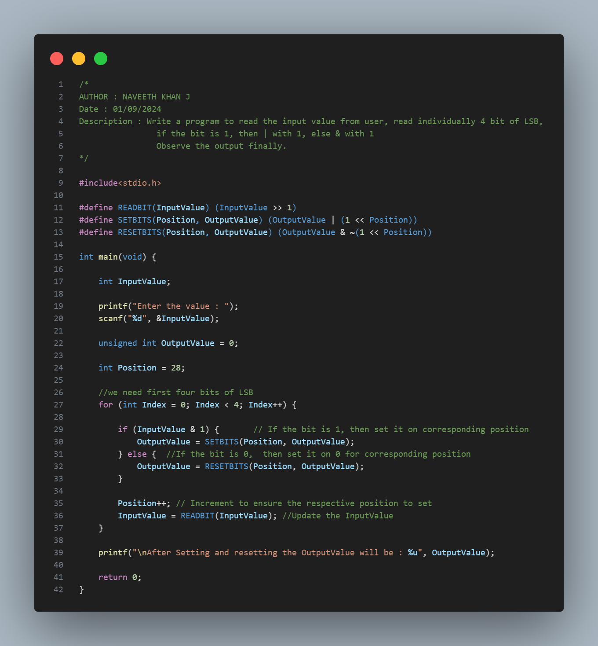

**Explanation:**

1. Get the user input and store it in a variable named InputValue.
2. Initialize the output variable OutputValue to 0.
3. Read each bit individually from InputValue, up to 4 bits, using the READBIT macro.
4. Define the SETBITS macro to set the respective bit at the specified position to 1 in OutputValue (most significant bits).
5. Define the RESETBITS macro to reset the respective bit at the specified position to 0 in OutputValue (most significant bits).
6. Print the value of OutputValue after all bit manipulations are complete.

**OUTPUT:**

